MediaTracker User Manual

This Software was made by: Korey Bibie

MediaTracker is a program designed to help users keep track of experienced media as sometimes It can be difficult to keep track of this content on your own. This document serves as a guide for anyone who may need it.

Part 1: The Main Menu

MediaTracker’s main menu consists of 3 options:

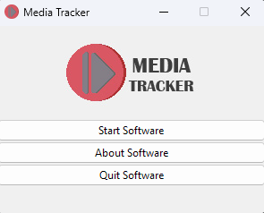

Those options are:

* Start Software
* About Software
* Quit Software

Let’s start with Start Software

Part 2: Main Software Screen

Inside of the Start Software option the user will be presented with a entirely new set of options: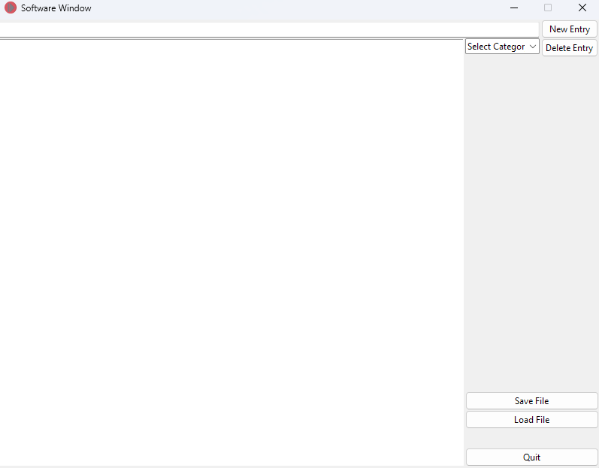

Let’s Navigate this screen from Top Left to Bottom Right, Starting on the top left we have our entry field, this field is used for adding anything to the container right below it, next to our entry field is our New Entry button, you can either Click that button or hit enter on your keyboard to append new entries to the container.

Next is our big box, this is the container, the container lets you see what you’ve added so far, next to the container is the categories, before you the user can do anything you must select one of six categories:

* Movies
* TV Shows
* Games
* Music
* Books
* Podcasts

Next to the categories drop down there is a delete entry button, to use this the user must first click onto an entry in the container and then either press delete or click the delete entry button.

At the bottom of the page there are two buttons, Save and Load, When you’re done adding items to your categories click save, you will then be prompted to save your file (as a \*.csv) to a location on your computer, afterwards you can load this file whenever you please (Please note loading functionality is currently unfinished and does not work properly as of 12/15/2024)

Finally there’s a quit button to close out the Main Software window.

Part 3: The About Software Screen

This screen serves to let the user know who made the software and what the purpose of the software is, that is all.

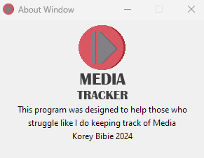

Part 4: The Quit Button

It closes out the software completely, pretty self explanatory.